Lab Cycle 1

1. Prepare a short note on the following hardware components.

a. Motherboard

A motherboard is **the main printed circuit board (PCB) in a computer**. The motherboard is a computer's central communications backbone connectivity point, through which all components and external peripherals connect. Motherboards can be found in virtually all computers, especially desktop and laptop PCs.

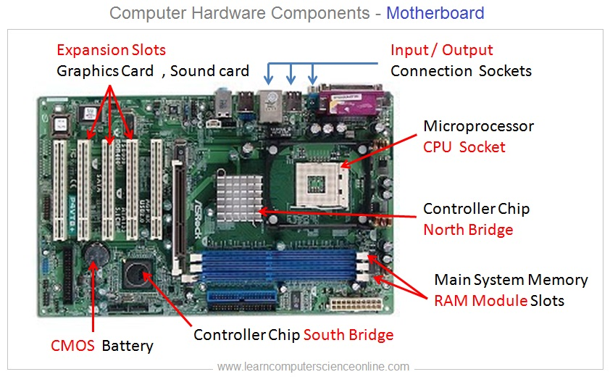

b. Internal storage devices

internal storage refers to the space available in a device to keep system files, applications, and user files.

i. RAM- different types

**RAM(Random Access Memory)** is a part of the computer’s Main Memory which is directly accessible by theCPU. RAM is used to Read and Write data into it which is accessed by the CPU randomly. RAM is volatile in nature, which means if the power goes off, the stored information is lost. RAM is used to store the data that is currently processed by the CPU. Most of the programs and data that are modifiable are stored in RAM.

## Static Random Access Memory (SRAM)

Data is stored in transistors and requires a constant power flow. Because of the continuous power, SRAM doesn’t need to be refreshed to remember the data being stored. SRAM is called static as no change or action i.e. refreshing is not needed to keep the data intact. It is used in cache memories.

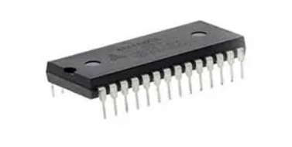

## **Dynamic Random Access Memory (DRAM)**

Data is stored in capacitors. Capacitors that store data in DRAM gradually discharge energy, no energy means the data has been lost. So, a periodic refresh of power is required in order to function. DRAM is called dynamic as constant change or action(change is continuously happening) i.e. refreshing is needed to keep the data intact. It is used to implement main memory.

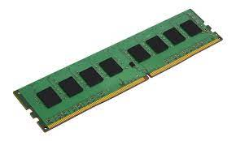

ii. ROM

ROM stands for Read-Only Memory. It is a non-volatile memory that is used to store important information which is used to operate the system. As its name refers to read-only memory, we can only read the programs and data stored on it. It is also aprimary memory unit of thecomputer system. It contains some electronic fuses that can be programmed for a piece of specific information. The information stored in the ROM in binary format. It is also known as permanent memory.

## Types of Read-Only Memory (ROM)

Now we will discuss the types of ROM one by one:

1. MROM (Masked read-only memory): We know that ROM is as old as semiconductor technology. MROM was the very first ROM that consists of a grid of word lines and bit lines joined together transistor switches. This type of ROM data is physically encoded in the circuit and only be programmed during fabrication. It was not so expensive.

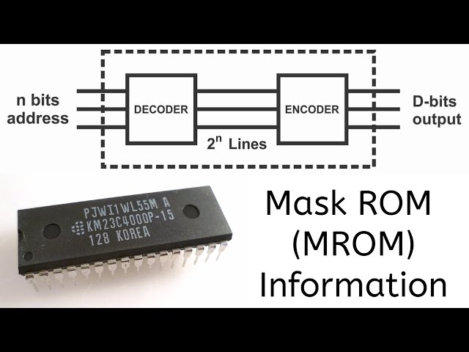

1. PROM (Programmable read-only memory): PROM is a form of digital memory. In this type of ROM, each bit is locked by a fuse or anti-fuse. The data stored in it are permanently stored and can not be changed or erasable. It is used in low-level programs such as firmware or microcode.

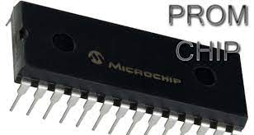

1. EPROM (Erasable programmable read-only memory): EPROM also called EROM, is a type of PROM but it can be reprogrammed. The data stored in EPROM can be erased and reprogrammed again by ultraviolet light. Reprogrammed of it is limited. Before the era of EEPROM and flashmemory, EPROM was used in microcontrollers.

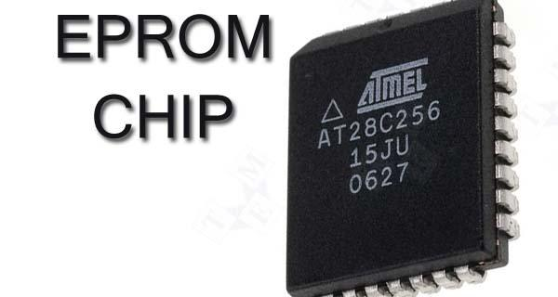

1. EEPROM (Electrically erasable programmable read-only memory): As its name refers, it can be programmed and erased electrically. The data and program of this ROM can be erased and programmed about ten thousand times. The duration of erasing and programming of theEEPROM is near about 4ms to 10ms. It is used in microcontrollers and remote keyless systems.

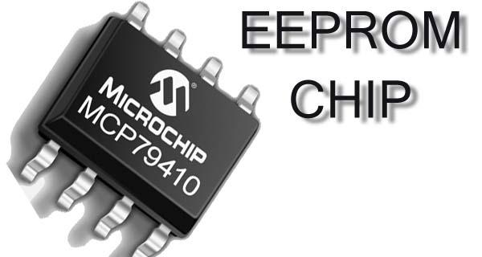

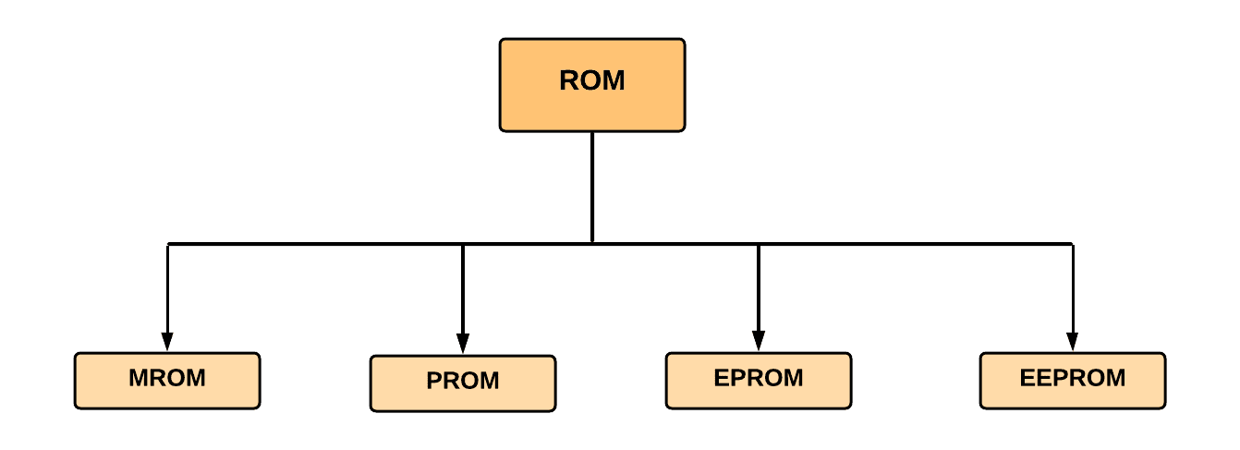

iii. Hard Disk

A hard disk drive, hard disk, hard drive, or fixed disk, is an electro-mechanical data storage device that stores and retrieves digital data using magnetic storage with one or more rigid rapidly rotating platters coated with magnetic material

There are two different types of hard drives used in computers as data storage devices: **hard disk drives (HDDs) and solid state drives (SSDs)**. Each uses different types of interfaces, such as Serial Advanced Technology Attachment (SATA), to store data and make it accessible to users.

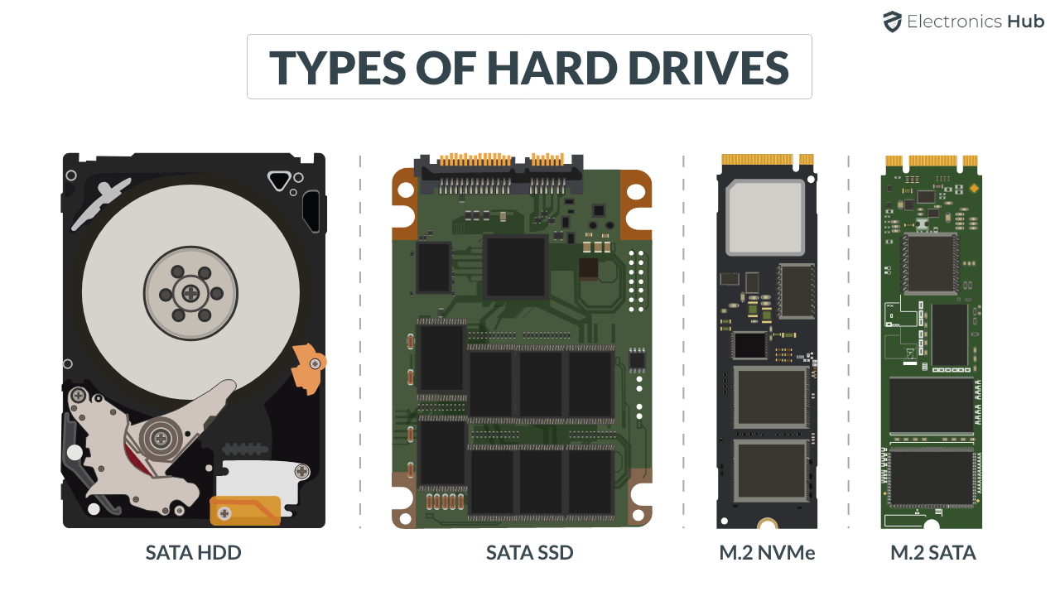

c. SMPS

A **switched-mode power supply** (SMPS), also called switching-mode power supply, switch-mode power supply, switched power supply, or simply switcher, is an electronic power supply that incorporates a switching regulator to convert electrical power efficiently.

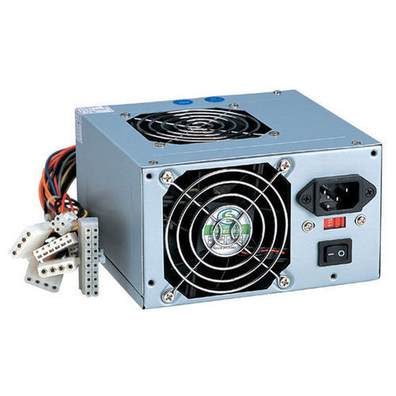

d. daughter cards

A daughter card (otherwise known as a controller card) is **a variation of circuit boards**. It gets added to the motherboard on a device to improve the device's functionality.

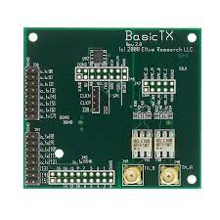

e. Bus slots

Alternatively known as a **expansion slot** or **expansion port**, a bus slot is a connection or port inside a computer on the motherboard or riser card. It provides an installation point for a hardware expansion card to be connected. For example, if you wanted to install a new video card in the computer, you'd purchase a video expansion card and install that card into the compatible expansion slot.

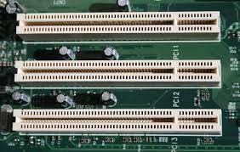

f. Interfacing ports

An **interfacing port** serves as a crucial link between a computer and external devices. These physical docking points allow seamless communication between the computer and peripherals. Common types of ports include **USB ports** (for connecting devices like mice, keyboards, and printers), **VGA ports** (for linking monitors), **Ethernet ports** (for network communication), and **audio sockets** (for microphones and speakers). These ports enhance a computer’s versatility, allowing it to adapt to various needs and are usually located on the exterior of the computer for easy connection or disconnection of devices without opening the case .

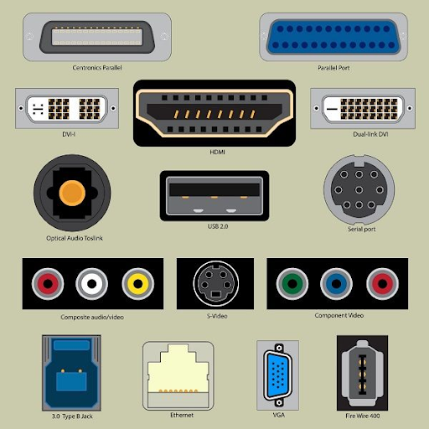

2. Write the specification for a desktop computer.

Desktop Computer Specification

1. Processor (CPU):

* Intel Core i5 or AMD Ryzen 5 series.
* Speed: 2.5 GHz or higher.

2. Memory (RAM):

* 8 GB DDR4 RAM.

3. Storage:

* 256 GB SSD.

4. Graphics Processing Unit (GPU):

* Integrated graphics or dedicated GPU with 2 GB VRAM.

5. Motherboard:

* Standard ATX or Micro-ATX.

6. Operating System:

* Windows 10 Home 64-bit.

7. Connectivity:

* Gigabit Ethernet, Wi-Fi (802.11ac), Bluetooth 4.2.

8. Ports:

* USB 3.0/3.1 Gen 1 ports, HDMI, DisplayPort.

9. Optical Drive:

* None (external drive optional).

10. Power Supply Unit (PSU):

* 400W or higher.

11. Cooling System:

* Stock CPU cooler, case fans.

12. Case:

* Mid-tower case with adequate airflow.

13. Accessories:

* Standard keyboard, mouse, and speakers.

14. Warranty:

* 1-year limited warranty.

Note: This specification provides a balance between performance, affordability, and functionality, suitable for general computing tasks, light gaming, and multimedia consumption.

3. Write the specification for a server computer.

Server Computer Specification

1. Processor (CPU):

* Intel Xeon or AMD EPYC series.
* Quad-core or higher, 2.5 GHz or faster.

2. Memory (RAM):

* 16 GB ECC DDR4 RAM.

3. Storage:

* 500 GB NVMe SSD (for operating system).
* 2 TB SATA HDD (for data storage).

4. Network Interface:

* Dual Gigabit Ethernet ports.

5. Operating System:

* Windows Server 2019 or Linux (e.g., CentOS, Ubuntu Server).

6. Remote Management:

* BMC for remote monitoring.

7. Redundancy and Reliability:

* Hot-swappable components.
* ECC memory.

8. Security Features:

* TPM for data protection.
* Firmware security measures.

9. Cooling System:

* Redundant cooling fans.

10. Rack Mountability:

* 1U or 2U rack-mount form factor.

11. Remote Access:

* Remote access software.

12. Warranty and Support:

* Extended warranty options.
* 24/7 technical support.

Note: This specification provides a reliable server setup suitable for small to medium-sized businesses or enterprise applications. Adjustments can be made based on specific requirements and scalability needs.

4. Write short note on the following.

a. Operating System

An operating system is system software that manages computer hardware and software resources, and provides common services for computer programs.An Operating System can be defined as an interface between user and hardware. It is responsible for the execution of all the processes, Resource Allocation, CPU management, File Management and many other tasks.

b. Linux

Linux is a Unix-like operating system renowned for its stability, security, and flexibility. Developed by Linus Torvalds in 1991, it is open-source, allowing users to modify and distribute its code freely. With a multitude of distributions tailored to various needs, Linux powers a vast range of devices, from servers to smartphones, making it a cornerstone of modern computing.

c. Ubuntu

Ubuntu is a user-friendly Linux distribution developed by Canonical Ltd. It offers a simple interface, extensive software availability, robust security features, and regular updates. Supported by a large community, Ubuntu is suitable for desktops, servers, and cloud deployments.

d. Virtual Machine

A virtual machine (VM) is a software emulation of a physical computer system. It allows you to run multiple operating systems simultaneously on a single physical machine. Each VM operates independently, with its own virtual hardware resources, such as CPU, memory, storage, and network interfaces. This enables you to create isolated environments for testing software, running legacy applications, or experimenting with different operating systems without impacting your primary system. VMs are widely used in software development, system administration, and cloud computing for their flexibility, scalability, and resource efficiency.

e. Kernel

The kernel is the core component of an operating system that acts as a bridge between software applications and the computer's hardware. It manages system resources, including CPU, memory, input/output devices, and file systems, and provides essential services such as process management, memory management, device drivers, and system calls. Essentially, the kernel is responsible for coordinating all operations within the operating system and ensuring that software programs can interact with hardware efficiently and securely.

f. Shell

A shell is a command-line interface that allows users to interact with an operating system by typing text commands. It interprets these commands and executes them, enabling users to perform various tasks such as navigating the file system, launching programs, and managing processes. Shells can also include features like scripting capabilities, command history, and customization options. In essence, the shell serves as a user's primary interface to control and manipulate the operating system and its resources.

g. Terminal

The Linux terminal, also known as the command-line interface (CLI), is a text-based interface used for interacting with the operating system. Users input commands via text, and the system responds with text-based output. It provides access to a wide range of powerful tools and utilities for tasks such as file management, system administration, software installation, and programming. The terminal offers features like command history, tab completion, and shell scripting, enabling users to efficiently navigate their systems and automate tasks.

h. Bash

Bash, short for "Bourne Again Shell," is a popular Unix shell and command language interpreter. It is the default shell for most Linux distributions and is widely used in Unix-like operating systems. Bash provides users with a command-line interface to interact with the operating system, allowing them to execute commands, run scripts, and automate tasks. It supports features such as command history, tab completion, variables, loops, conditionals, and functions, making it a powerful tool for both interactive use and scripting purposes. Bash is highly customizable and extensible, offering users the flexibility to tailor their command-line environment to their needs.

i. Shell scripting

Shell scripting involves writing scripts using commands specific to a shell (like Bash), enabling automation of tasks and management of system configurations in Unix-like environments, enhancing productivity and efficiency.

5. Steps to create a Shell Script in linux.

Here are the steps to create a shell script in Linux:

* Create a new file: Use the touch command to create a new shell script file (e.g., my_script.sh).
* Make it executable: Use chmod +x my_script.sh to grant execution permissions.
* Edit the script: Open the file and add your desired commands (e.g., echo, ls).
* Save the changes.
* Run the script: Execute it with ./my_script.sh.

6. What is the extension of shell script.

The extension commonly used for shell scripts is ".sh". For example, a shell script file might be named "test.sh". However, it's important to note that the extension is not strictly required for a shell script to function.

7. What is shebang ?

A shebang (also known as a hashbang or sha-bang) is the #! character sequence at the beginning of a script in Unix-like operating systems. The shebang is followed by the interpreter or the command that should be used to execute the script.

8. How to put your comments in your script.

Any line starting with a hash (#) becomes a comment. Comment means, that line will not take part in script execution.

9. How to execute a shell script.

* Open the terminal. Go to the directory where you want to create your script.
* Create a file with **.sh** extension.
* Write the script in the file using an editor.
* Make the script executable with command **chmod +x** <**fileName**>.
* Run the script using ./<**fileName**>.

10. Write a shell script to display your name .

#!/bin/sh

# Author : Ajo Jojo

echo "What is your name?"

read PERSON

echo "Hello, $PERSON"